**NAME**  : RUBIKA M

**DEPARTMENT**  : INDUSTRIAL BIOTECHNOLOGY

**COLLEGE**  : GOVERNMENT COLLEGE OF

TECHNOLOGY

**NAAN MUDHALVAN COURSE** : DIGITAL MARKETING

**NAAN MUDHALVAN ID** : F65C07DBAFEE284BE684F046700ABCB1

**ASSIGNMENT ON DIGITAL MARKETING**

1. Create a blog or website using blogspot and wordpress.Customize the theme design and post new article with 500 words.

Wordpress:

<https://mywindin.wordpress.com/2023/10/30/textile-industries/>

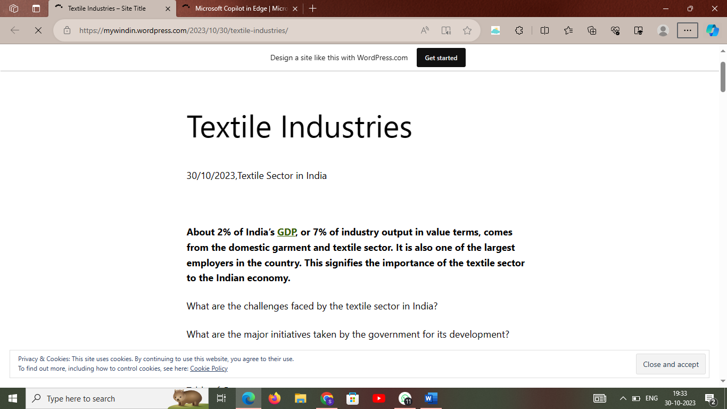

2.Create a new facebook business page and post one social media poster for your brand.

<https://business.facebook.com/latest/home?asset_id=112199285320807>

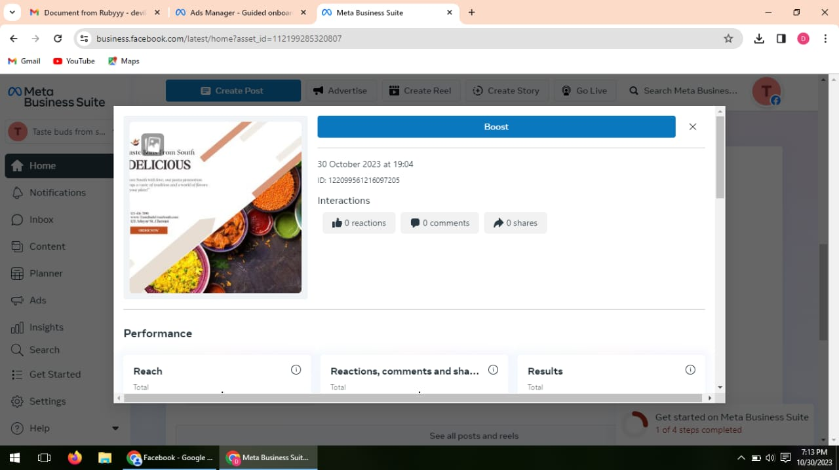

3.Create and design a social media advertisement poster using canva.

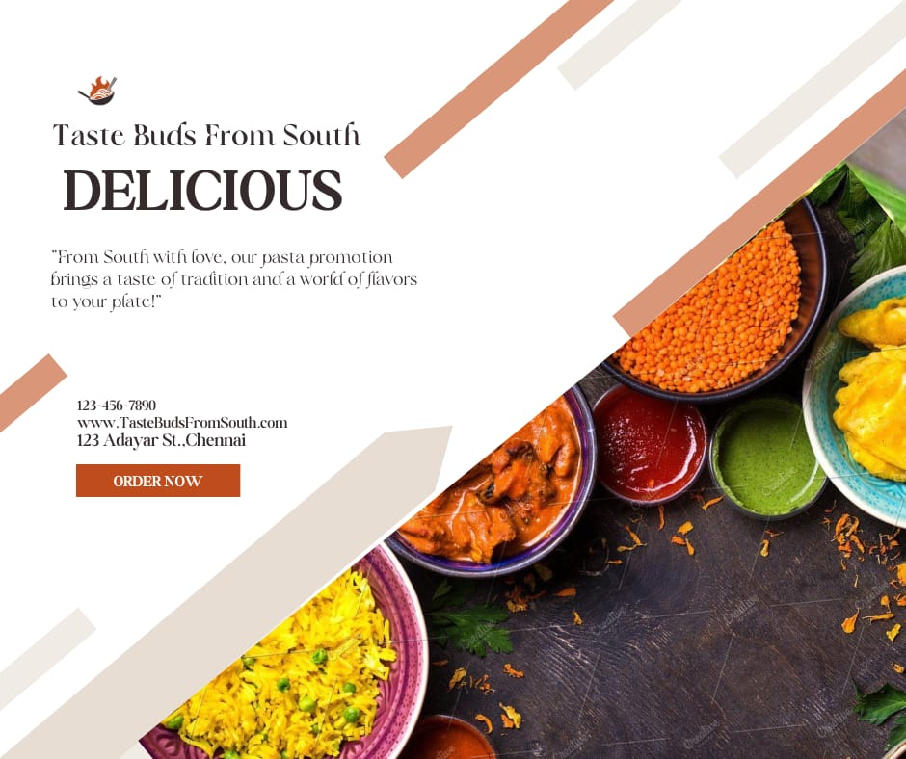

4. Create email newsletter design using Mailchimp or canva tool.

